Capstone 3 – Image Classification: Fish

1. **Objective:**

To develop a generalized, predictive model that can identify and differentiate between different types of fish species that share similar characteristics. The ideal model has a myriad of potential use cases that include the following:

1. High volume fish processing plant: ability to dynamically identify and separate different (in tandem with robotics) fish species to optimize the handling and processing of fish
2. Use for identification of fish species for environmental conservation efforts: this would require augmentation of the existing model to account for different environmental contexts
3. Potentially leverage existing model to develop a more sophisticated model that can accurately measure the dimensions (length and width) of the fish as well as the weight
4. **Assumptions and Exclusions:**

*B1. Key Assumptions/Comments 🡪*

* The context (background noise) has been limited; as one randomly investigates a pool of images, you will notice that the background is relatively consistent; this can most certainly be a problem when attempting to apply this model to a larger population of pictures
* The orientation and general size of the fish varies significantly which supports a more robust model
* No missing values

*B2. Key Exclusions* 🡪

* N/A

1. **Data Wrangling, EDA and Preprocessing:**

*C1. Data Collection, Wrangling and EDA 🡪*

* Downloaded the dataset from Kaggle 🡪 citation is denoted below
  + title={A Large-Scale Dataset for Fish Segmentation and Classification}
  + author={Ulucan, Oguzhan and Karakaya, Diclehan and Turkan, Mehmet}
  + booktitle={2020 Innovations in Intelligent Systems and Applications Conference (ASYU)}
  + pages={1--5}
  + year={2020}
  + organization={IEEE}

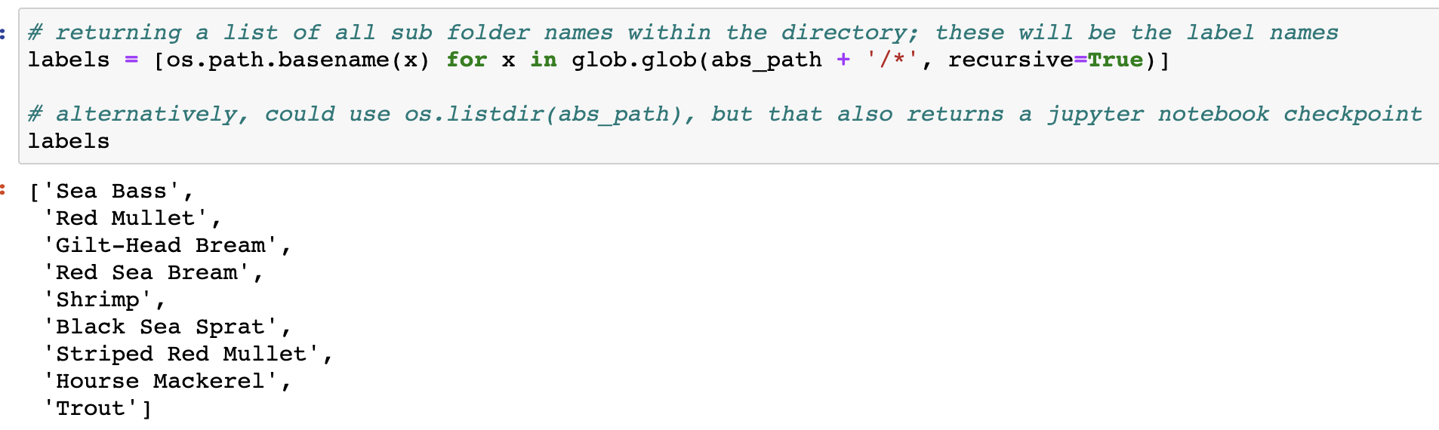

**Fig. 1** – Species Included in the Model

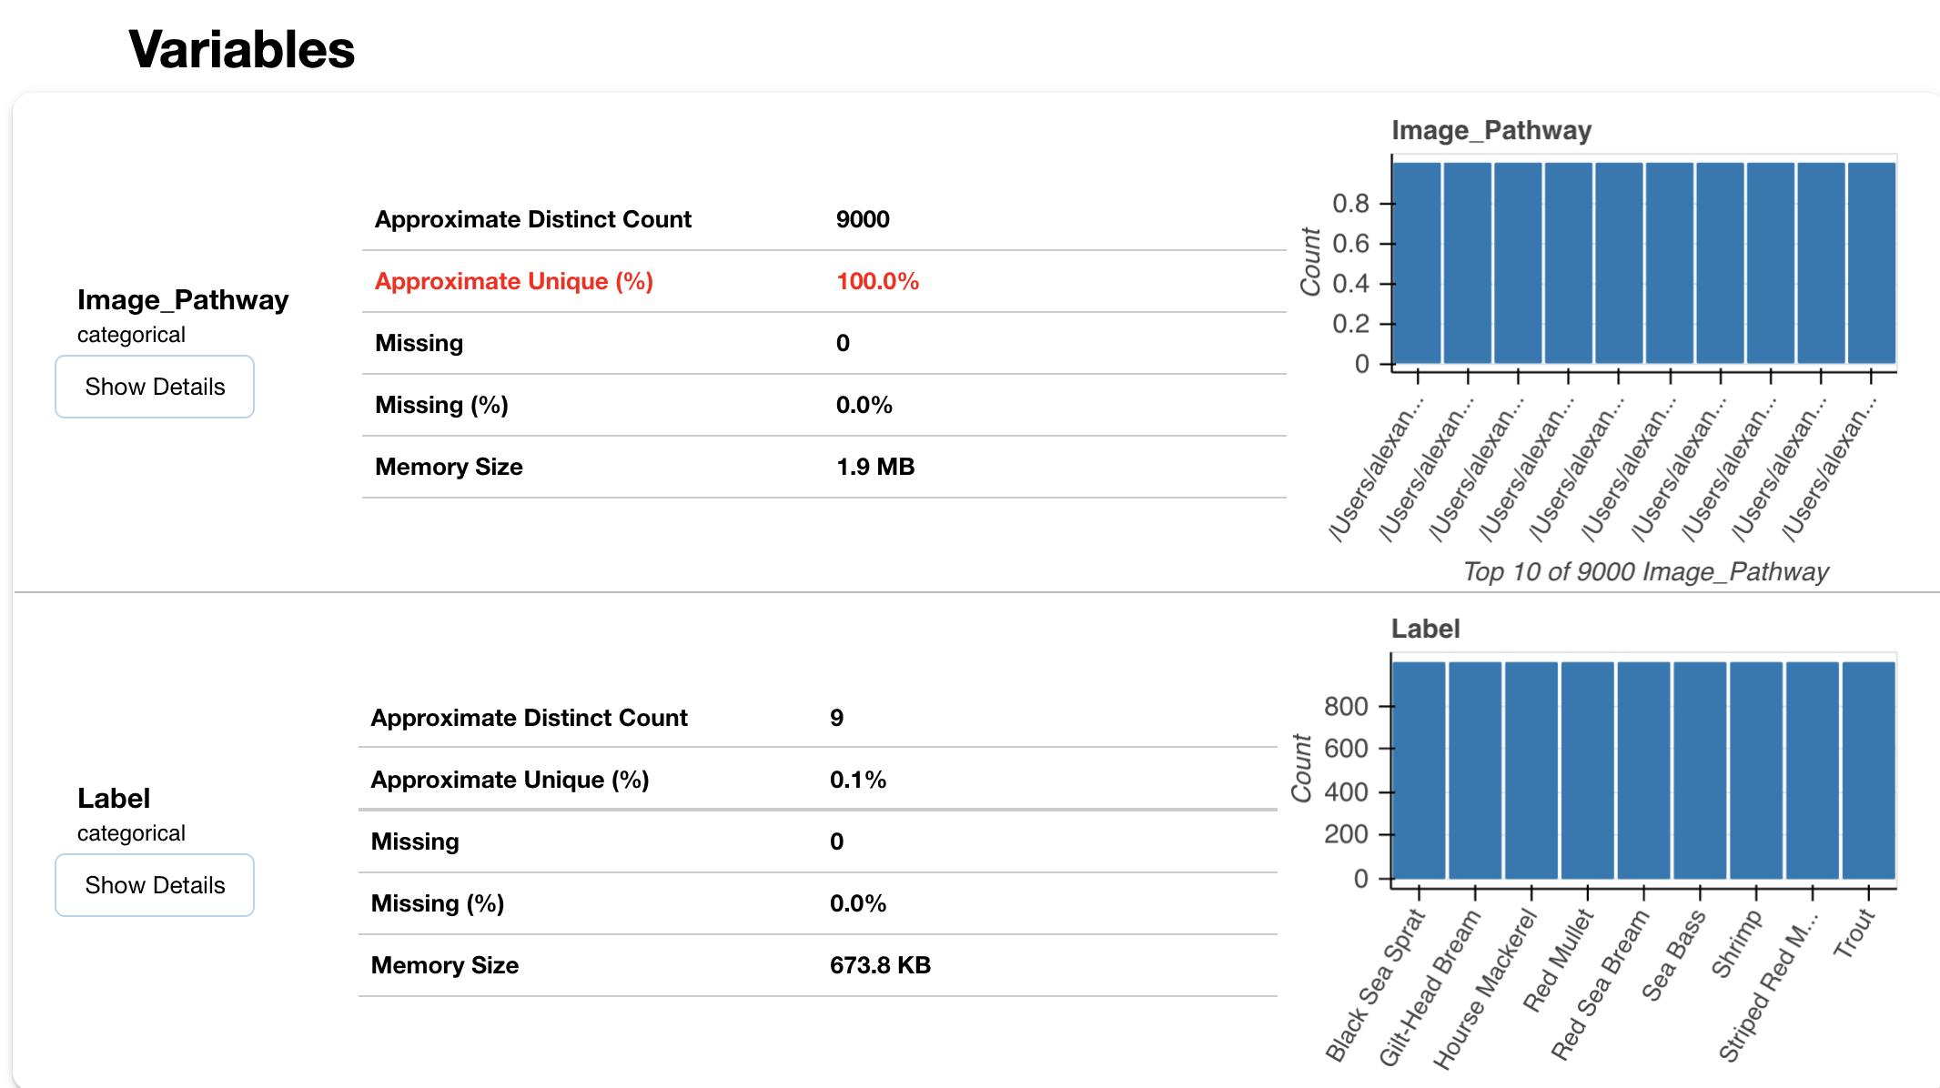

**Fig. 2 –** Distribution of Images (1000 per Species)

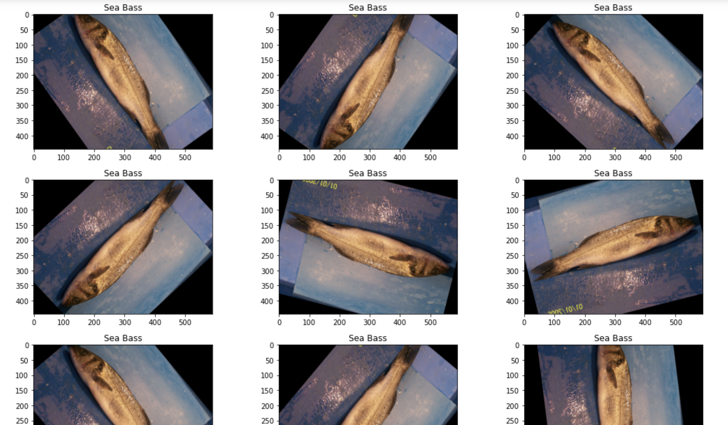

**Fig. 3 –** Inspection of Sea Bass Images

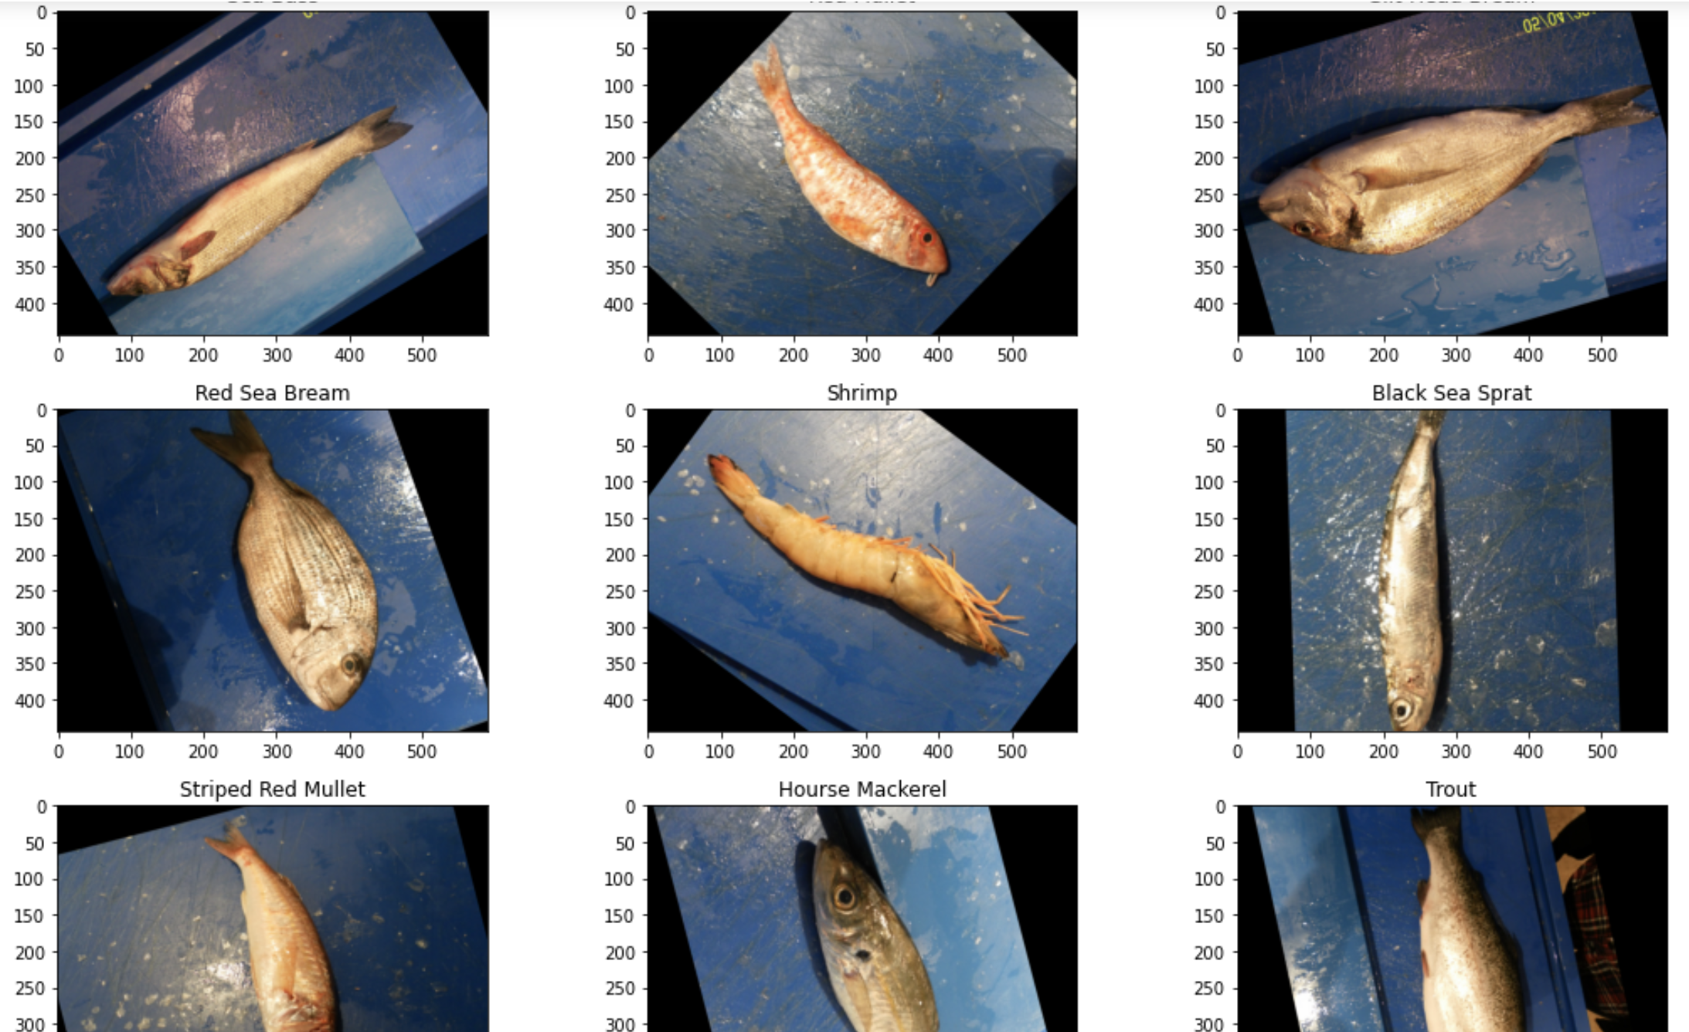

**Fig. 4 –** One Image of Each Fish Species

*C2. Preprocessing 🡪*

* After loading in the images and mapping their associated labels and inspecting a small sample, it was time to go ahead and start splitting the data into a training set, validation set and testing set
* First, I started by doing a 70/30% split of training/testing

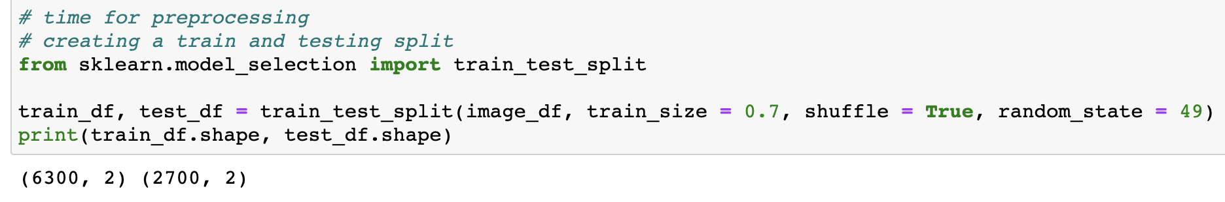

**Fig. 5** – Splitting into Training and Testing DataFrames

* Next, I went ahead and built out the required generators for processing the images

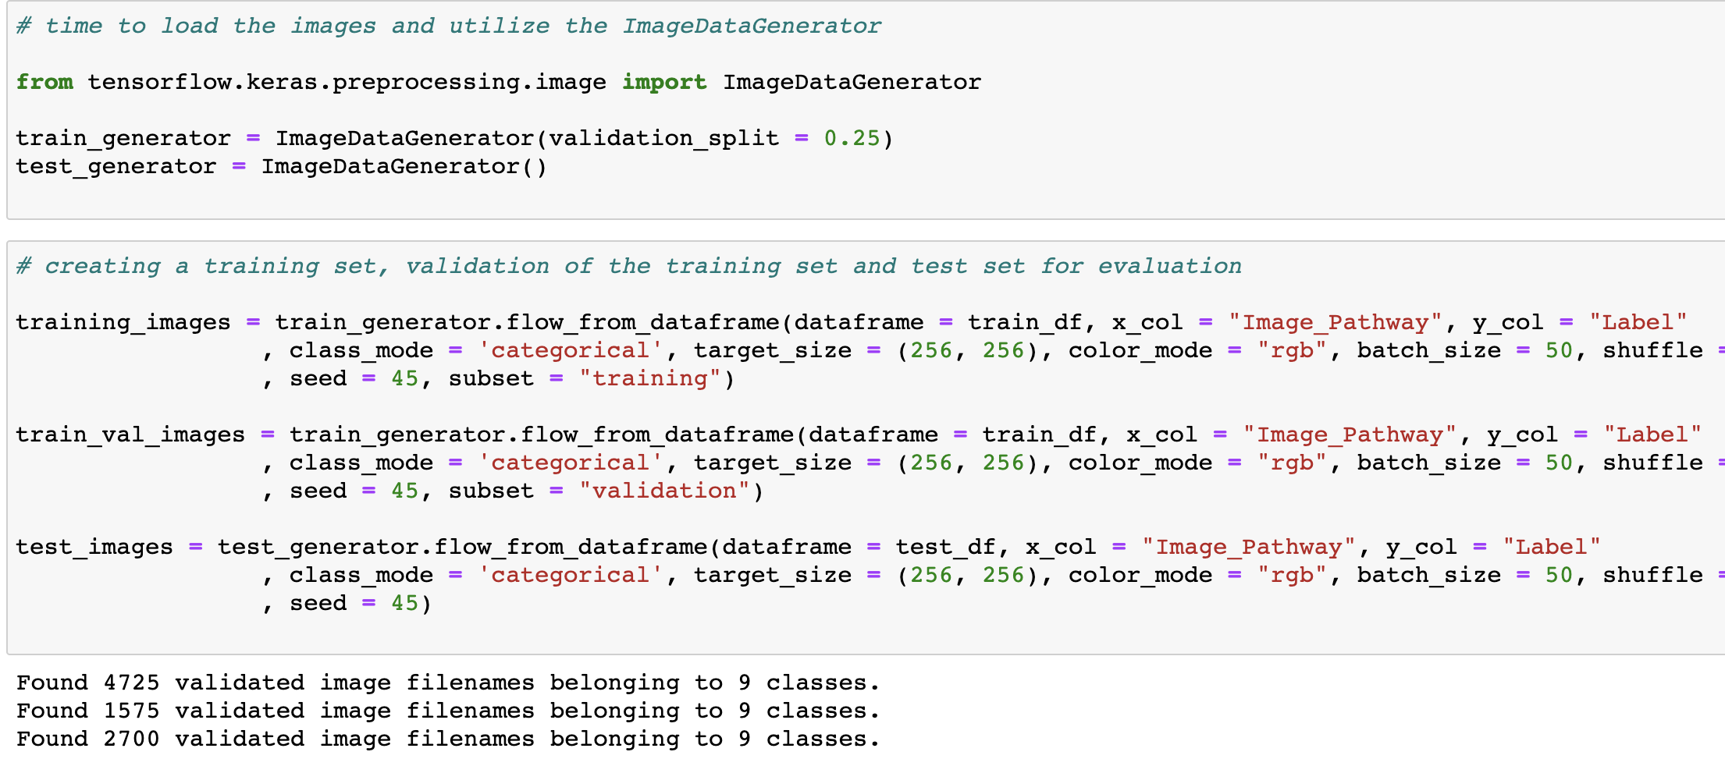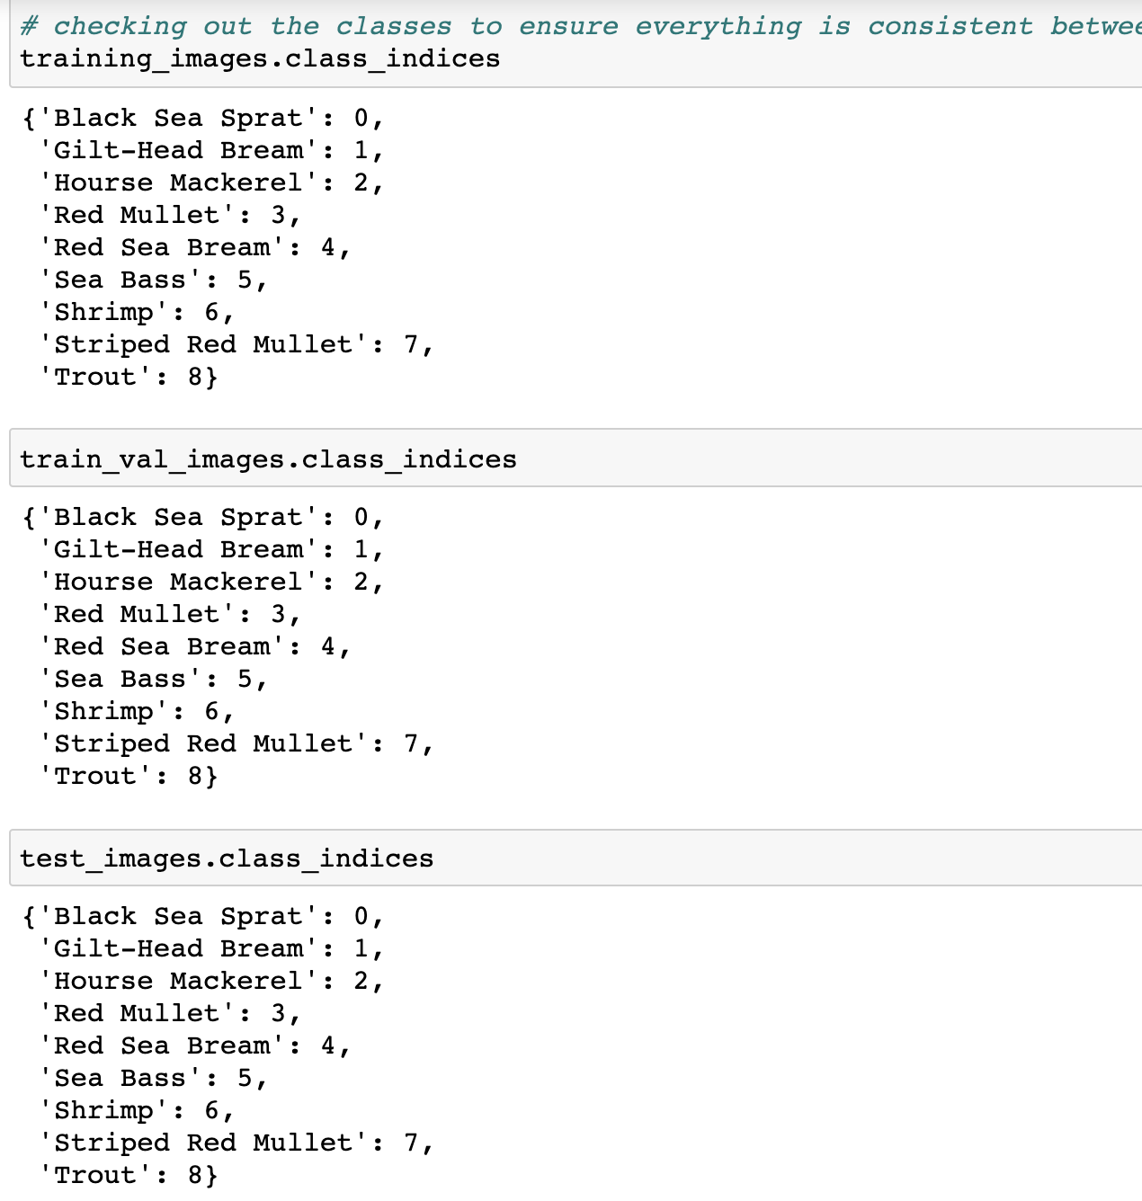

**Fig. 6** – Validating the splitting and classes

* You can see an example of the augmentation below

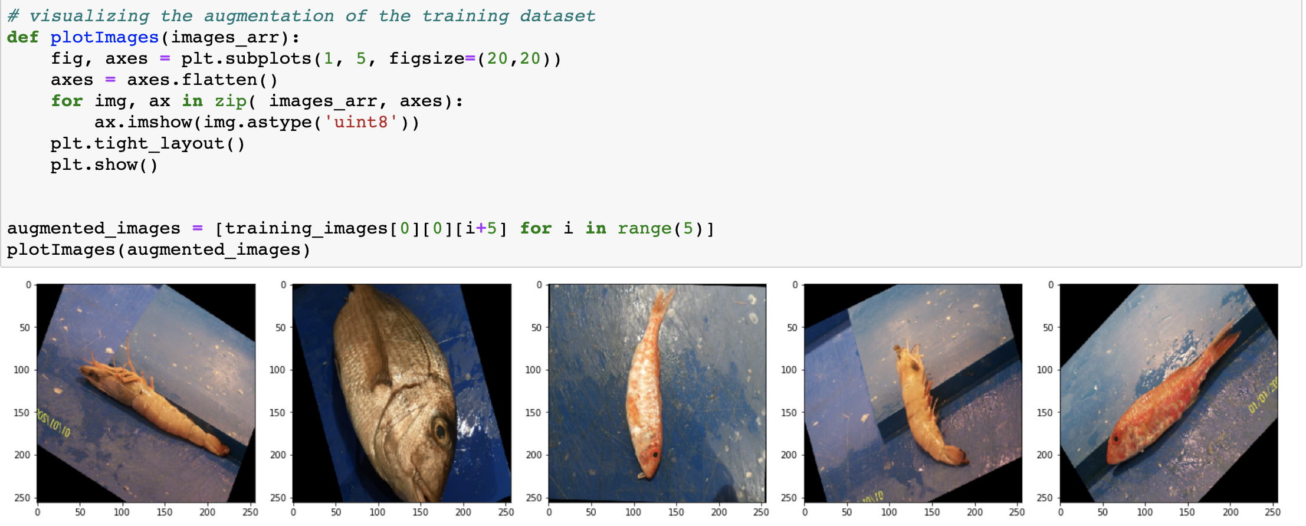

**Fig. 7** - Preprocessing Augmentation

* The dataset is now ready for modelling; I elected to build a model without leveraging a pre-trained model. I only did this to get a better understanding of how to compile/build and apply the model

1. **Modelling:**

* The dataset is now ready for modelling; I elected to build a model without leveraging a pre-trained model. I only did this to get a better understanding of how to compile/build and apply the model

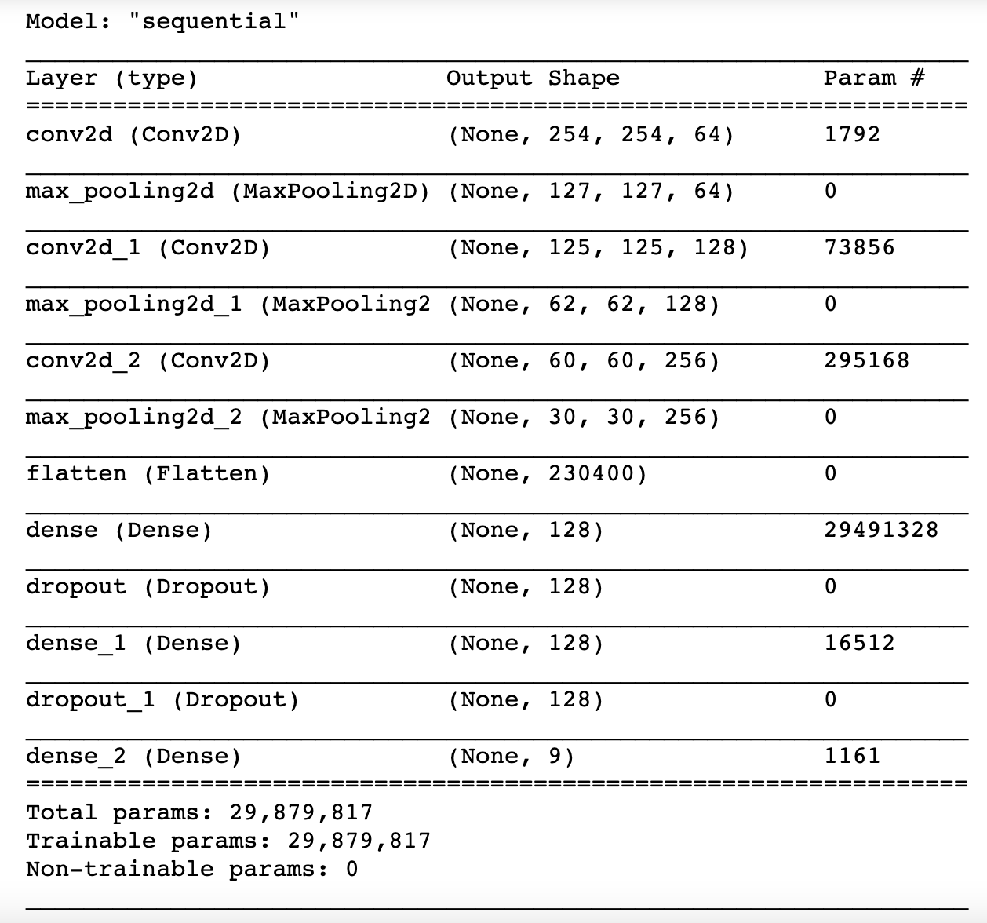

**Fig. 8 –** Model Setup Params

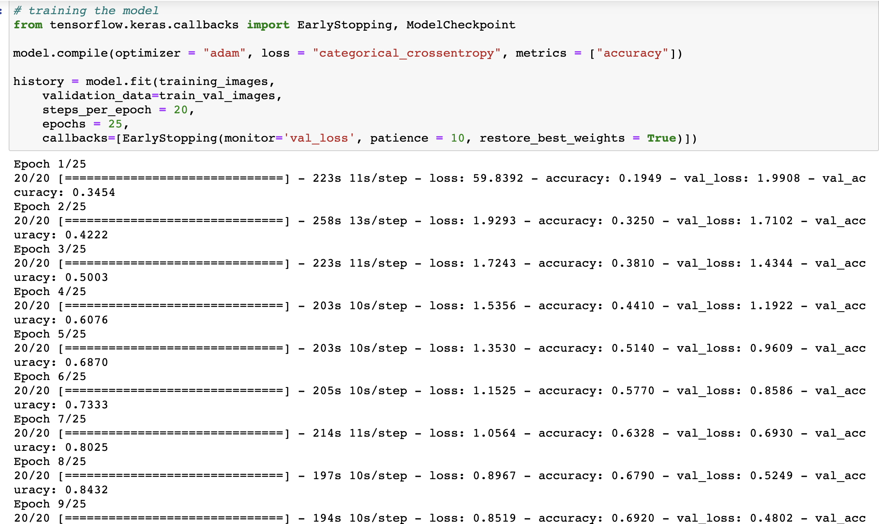

**Fig. 9 –** Initial Training

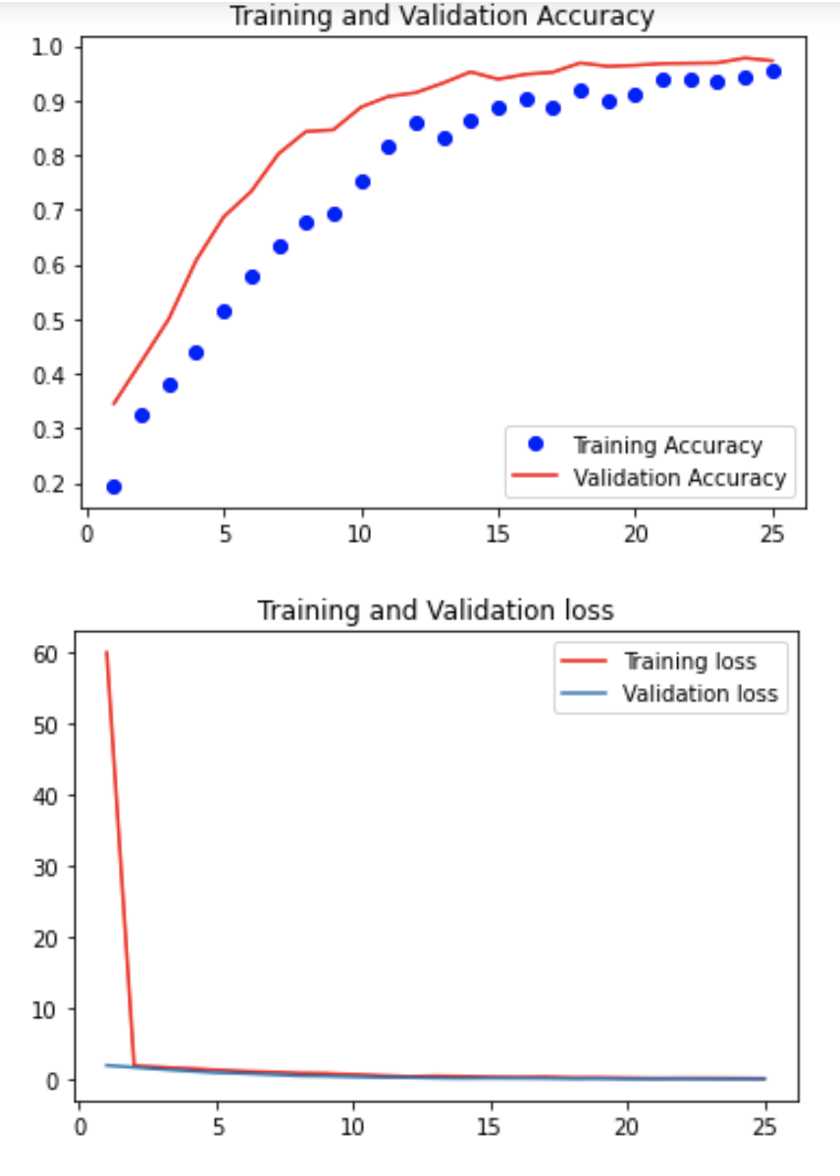

**Fig. 10 –** Validation/Training Loss and Accuracy

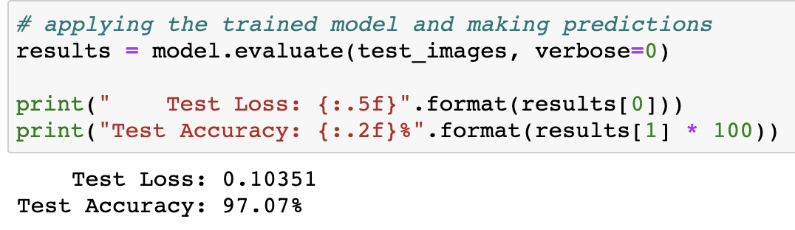

**Fig. 11** – End Results

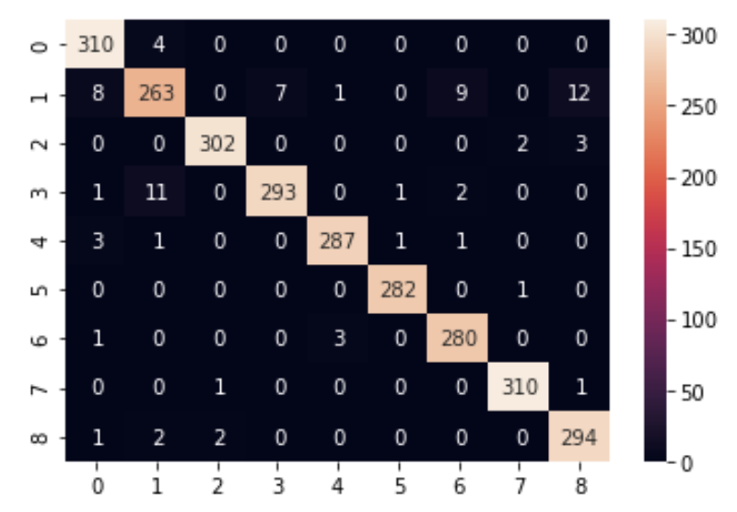

**Fig. 12** – Confusion Matrix

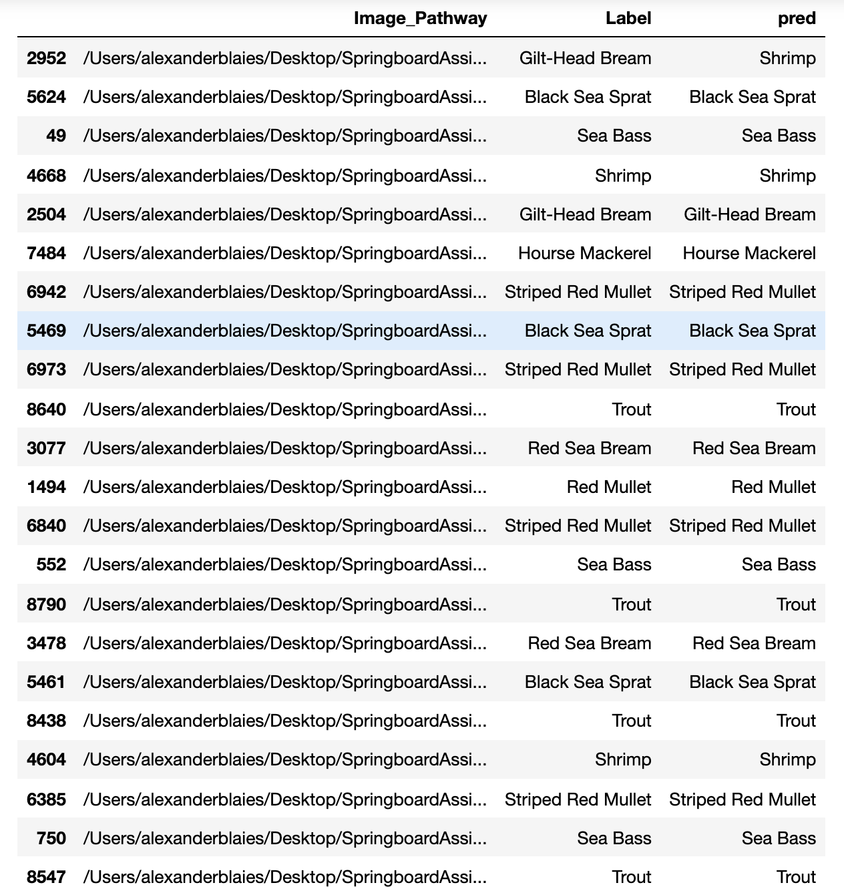

**Fig. 13** – DataFrame Inspection

1. **Lessons Learned and Comments:**

* This project served as a great introduction into image classification via leveraging Keras
* Based on the results shown above, this model does a great job at identifying individual species with similar characteristics
* It should be noted that I do believe that this model can be improved upon by: including different background contexts (change in lighting, scenery, etc.)
* Also, I did not account for outliers which could potentially further optimize the model
* Due to the computational expense, I chose to limit the epochs and validation steps included within the model; with more convolutional layers, this model could be more accurate